1. Write a query that displays all flights of a specific airline.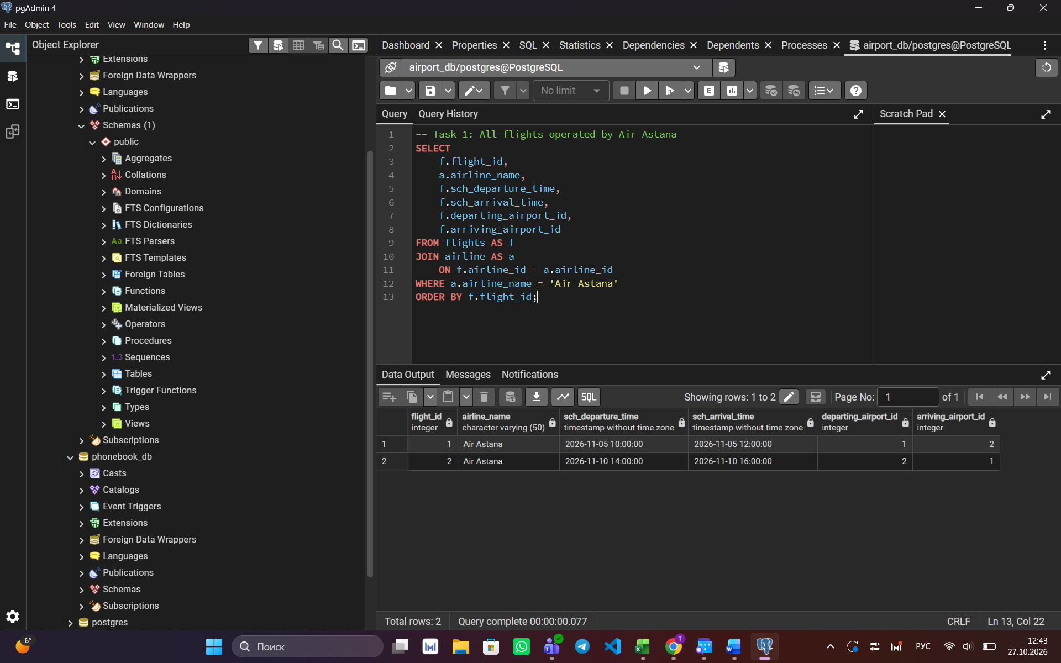

2. Compose a query to obtain a list of all flights with the names of departure airports.

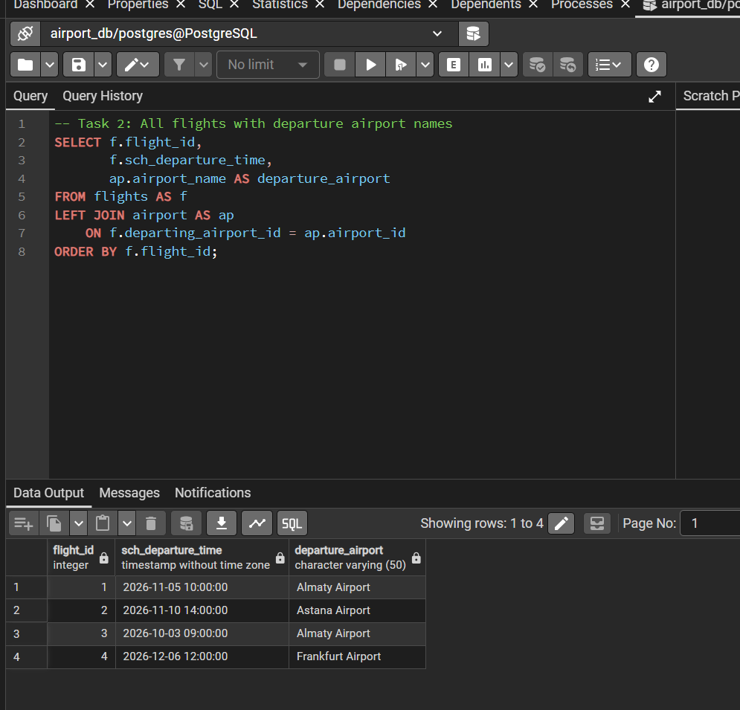

Create a query that finds all airlines that have no flights scheduled for the next month
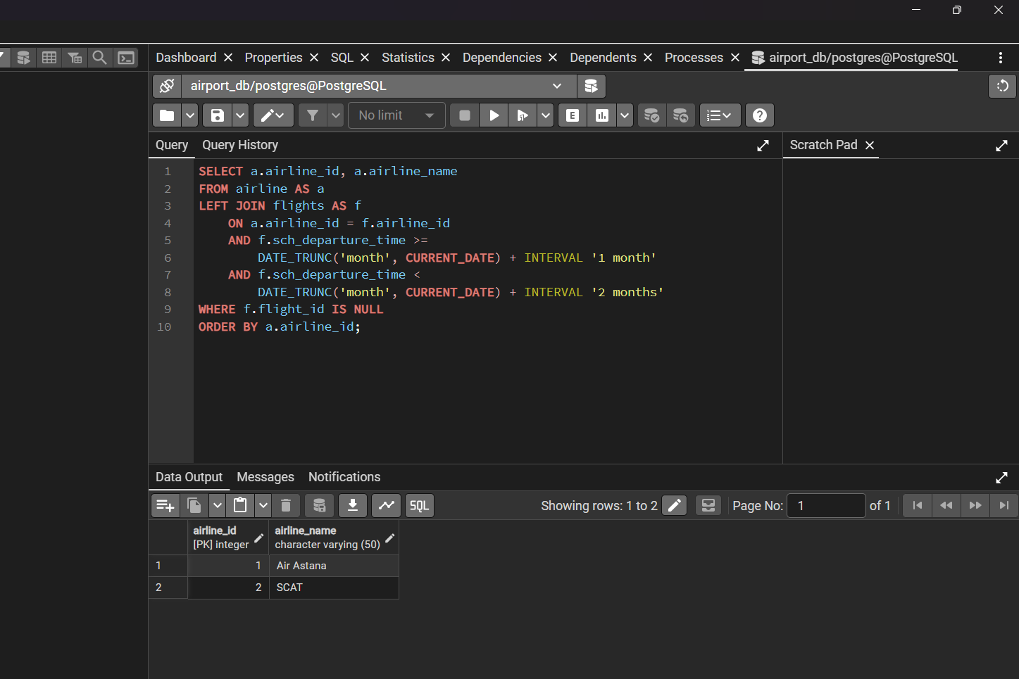

Create a query to display a list of passengers on a specific flight.
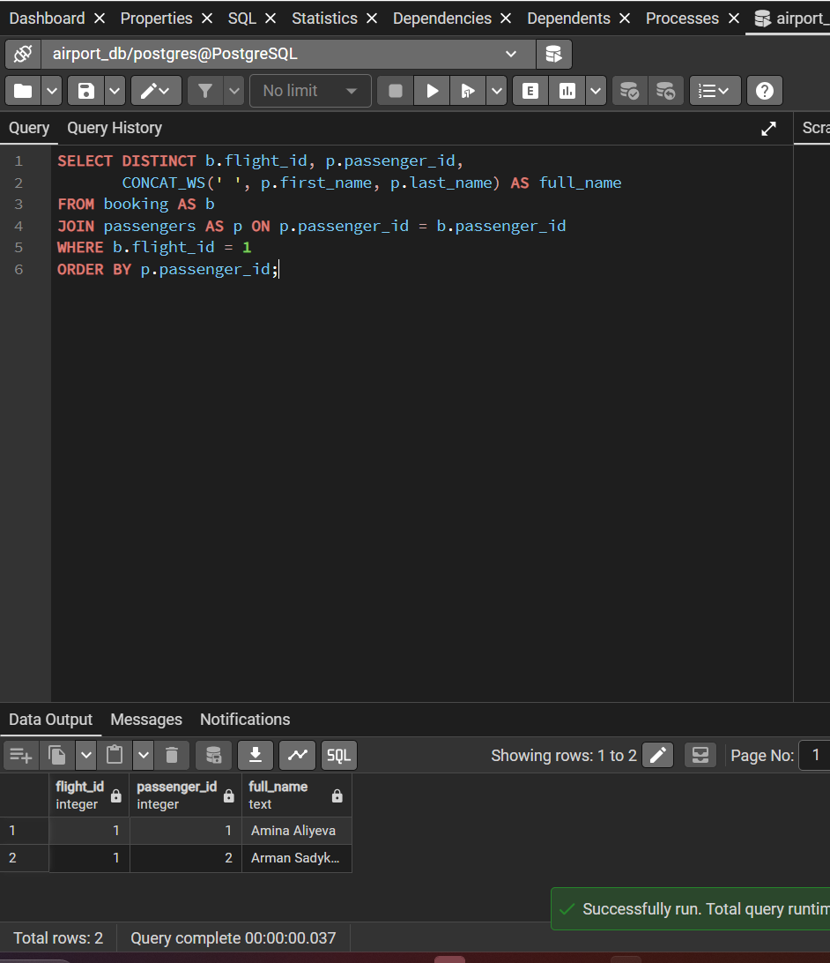
- Write a query that calculates the average, total, maximum and minimum price of tickets for each flight.
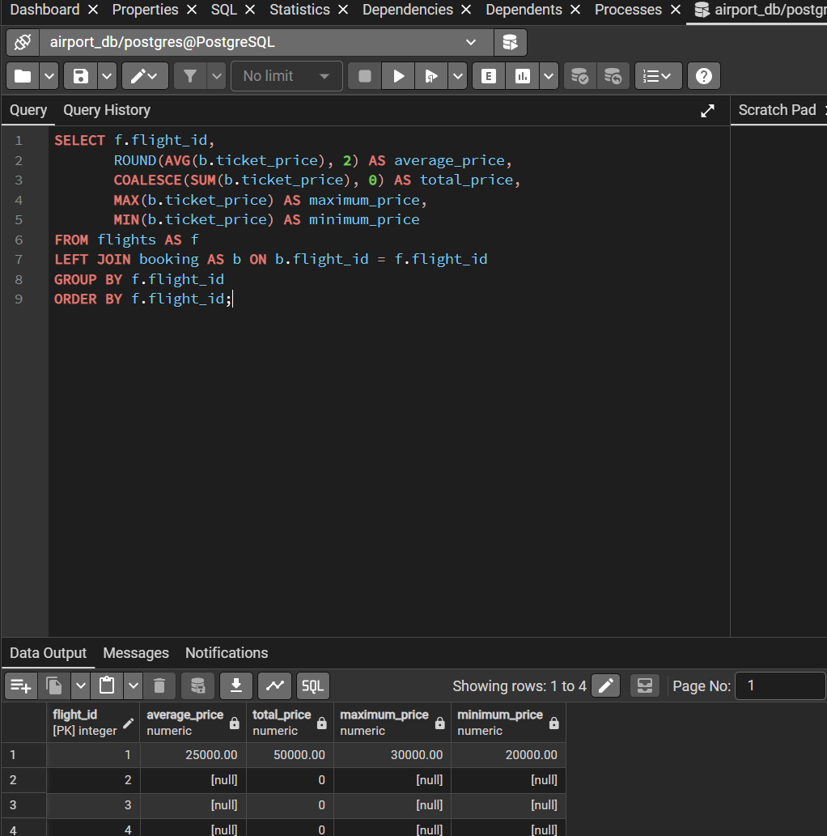

- Create a query that shows all flights flying to a specific country by combining flights, airports and airline, and using the condition on the country name.

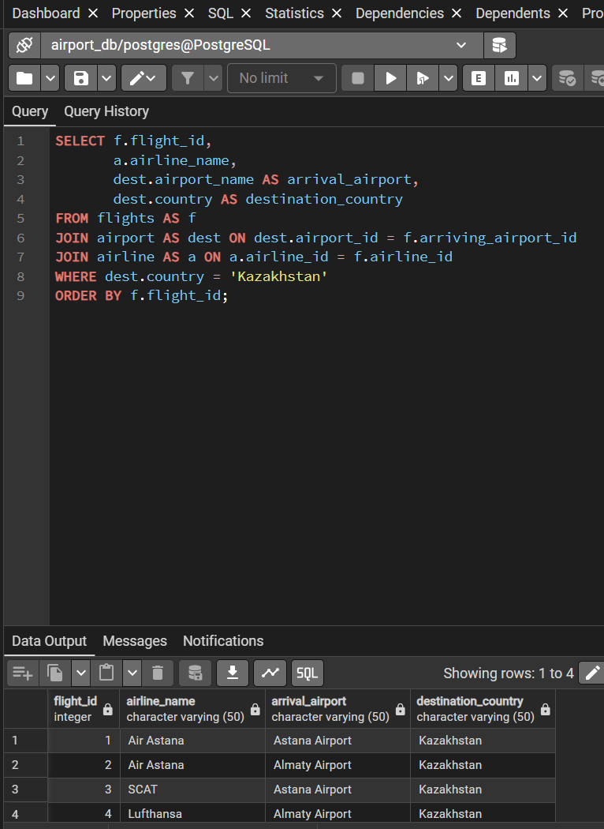

Display a list of minor passengers and their arrival destination
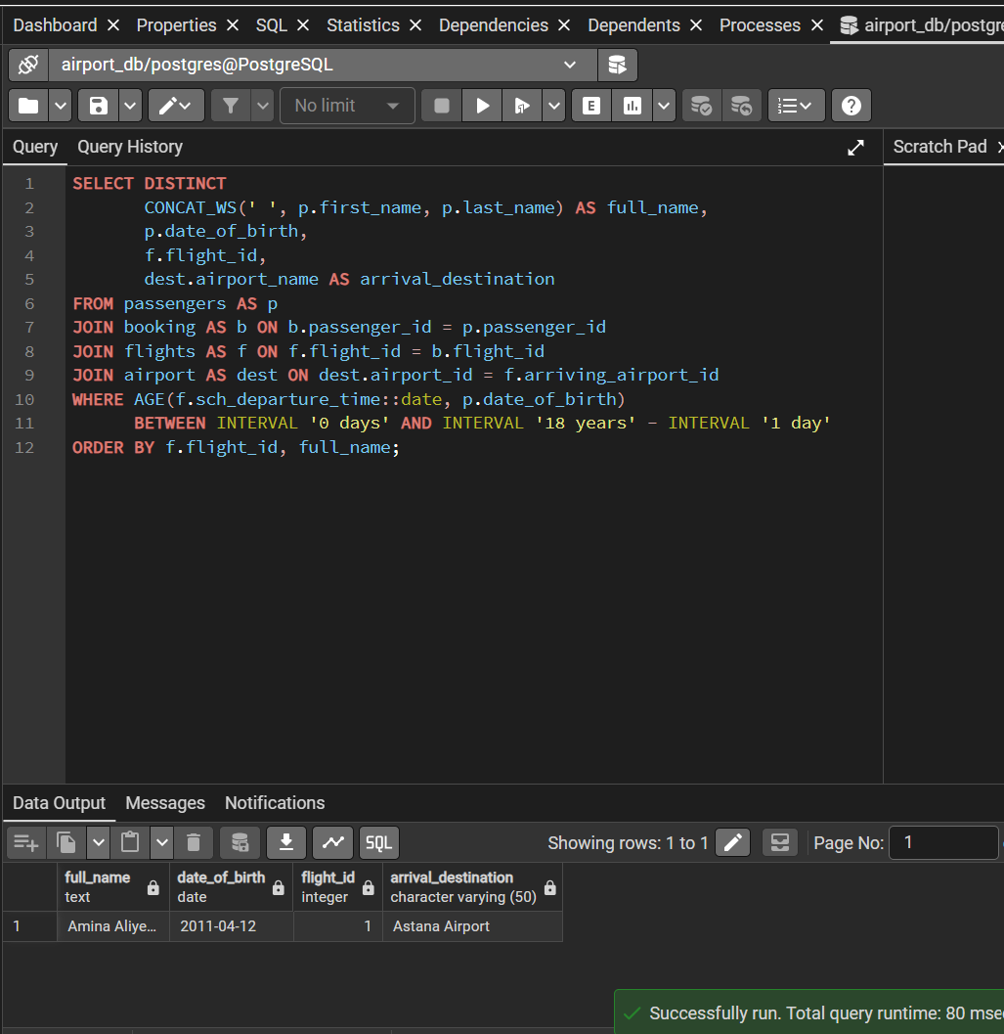
Display the passenger’s full name, passport number, and the passenger’s current time of arrival at the destination.
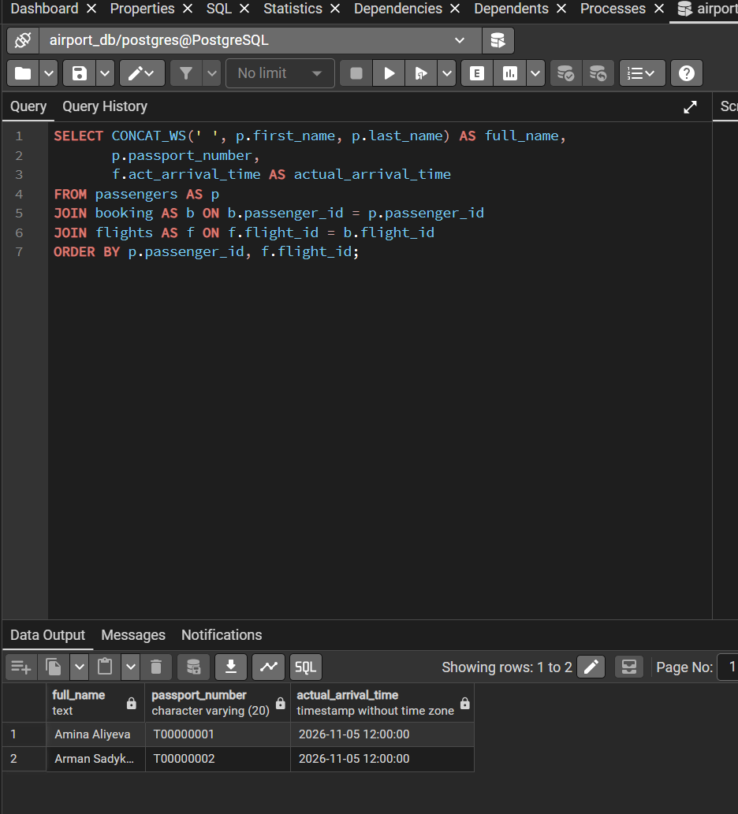

Print a list of flights where the airline's home country and origin country are the same. Group them by the airport country.
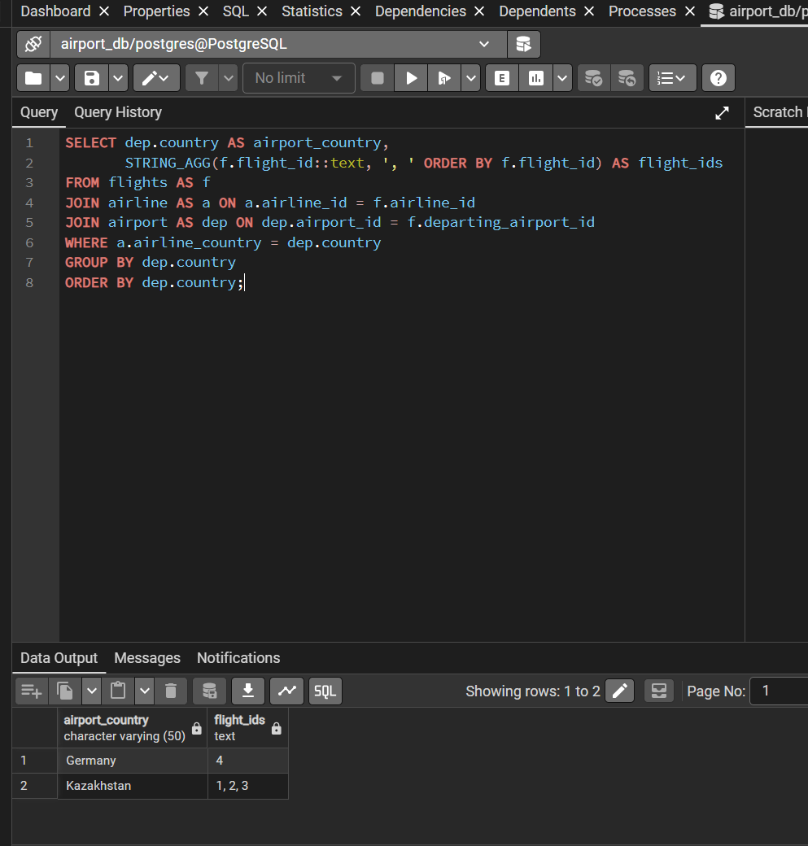
- Write a query that lists each flight number, airline name, departure airport, and arrival airport by joining the relevant tables.
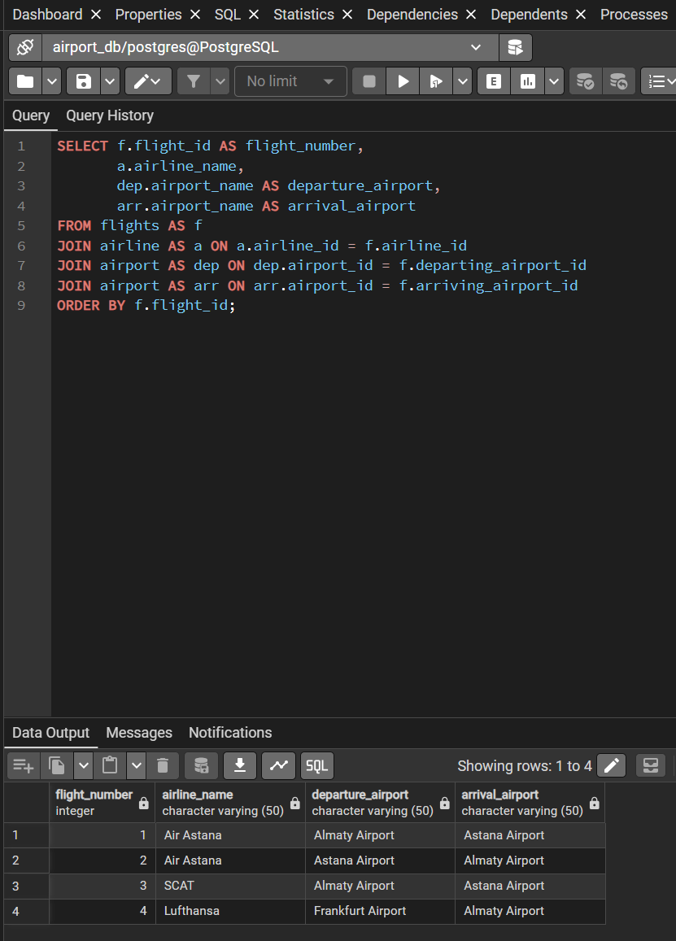

11. Display all passengers who have booked tickets for flights operated by a specific airline, including the passenger's full name and flight number.
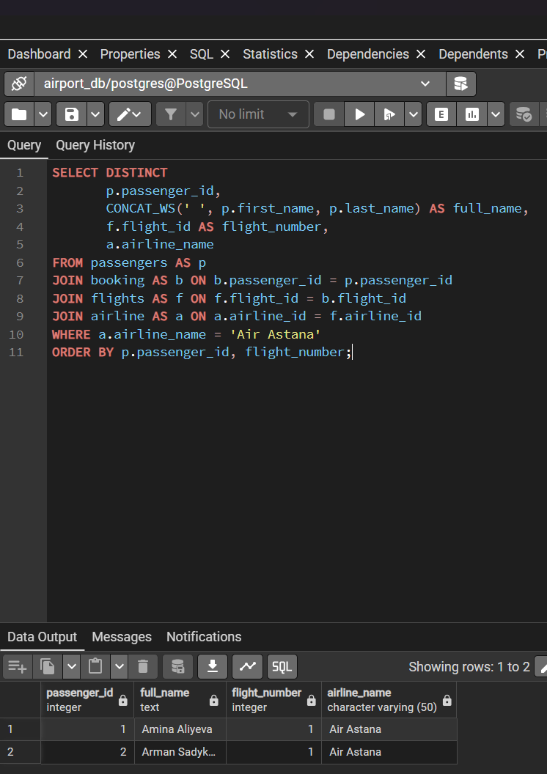

- Create a query that shows each flight's number, destination country, and number of passengers booked on that flight. Include flights with no booked passengers.
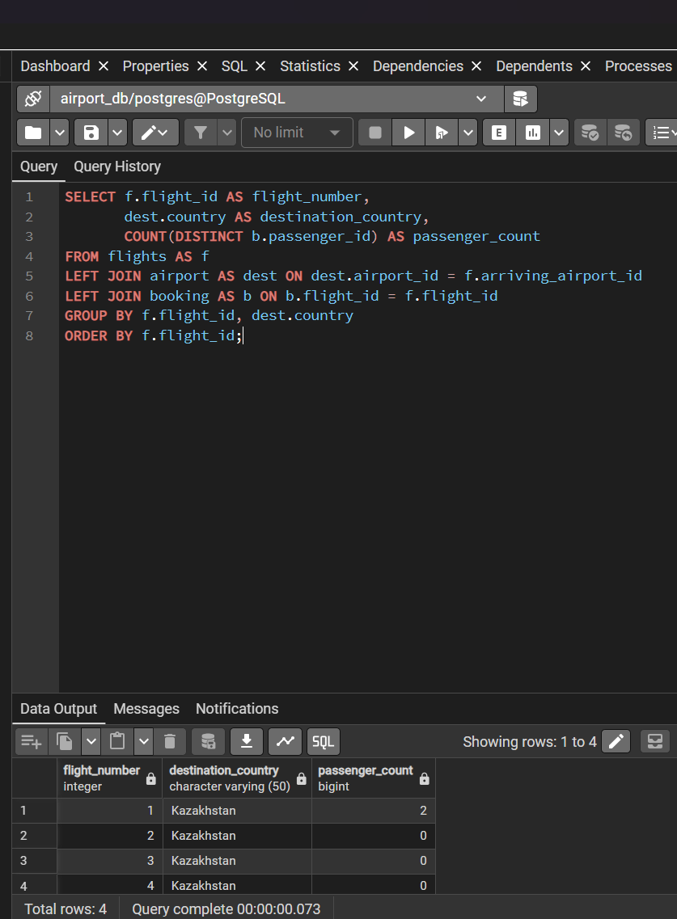

13. Find passengers who have not booked any tickets, using an appropriate JOIN operation.
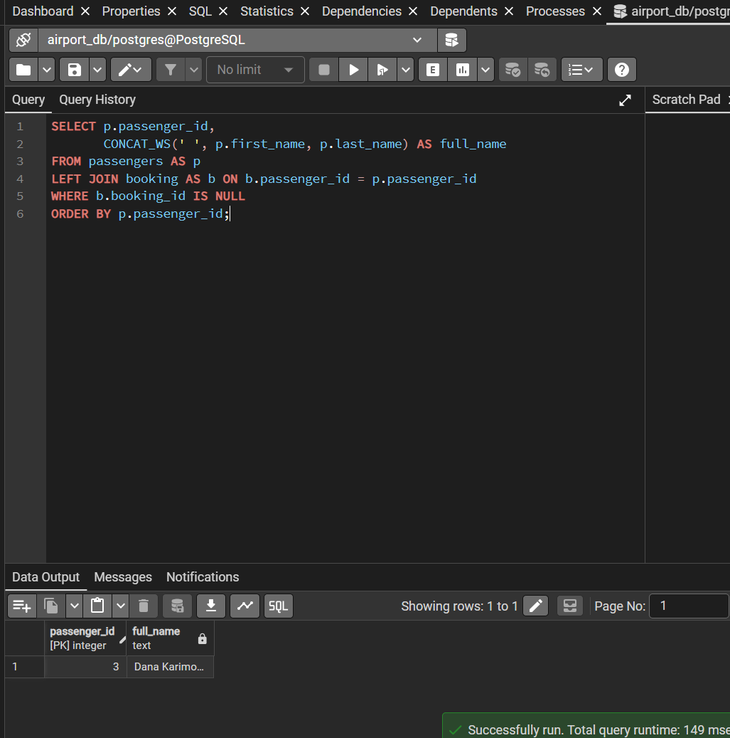

14. Display each airline and the total number of flights it operates, including airlines that currently have no flights.
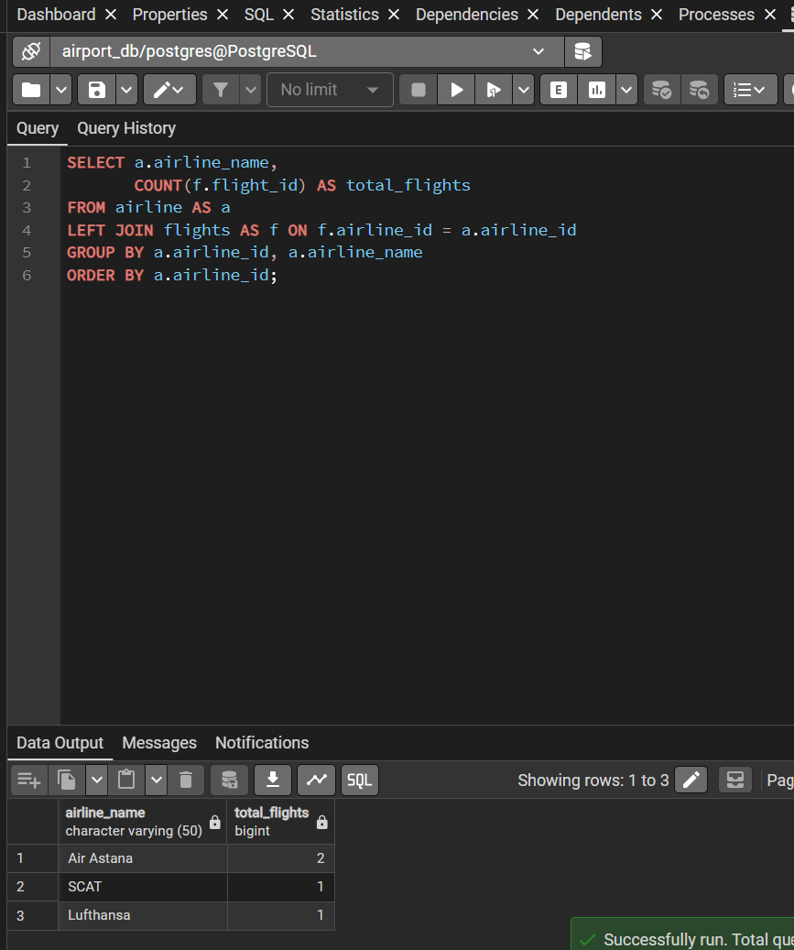

15. List flights departing from airports in a specified country and show the airline name, flight number, and departure airport city.


